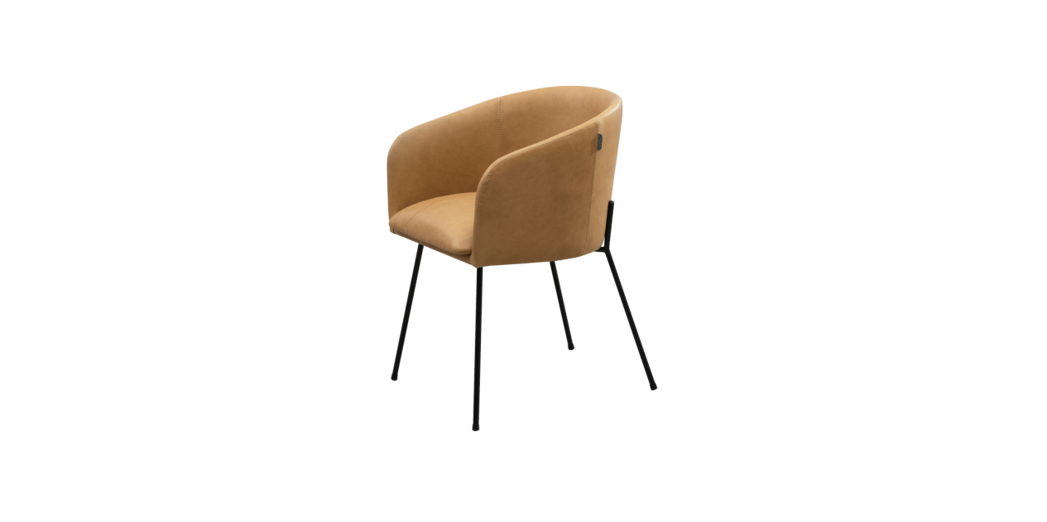

$275,67Featuring graceful curves, the Z-C07 chair with armrest will embrace you into its comfy seat. The chair is perhaps not ideal for small spaces, but its profile has both elegance and a fresh look which harmonizes well with the surroundings.

